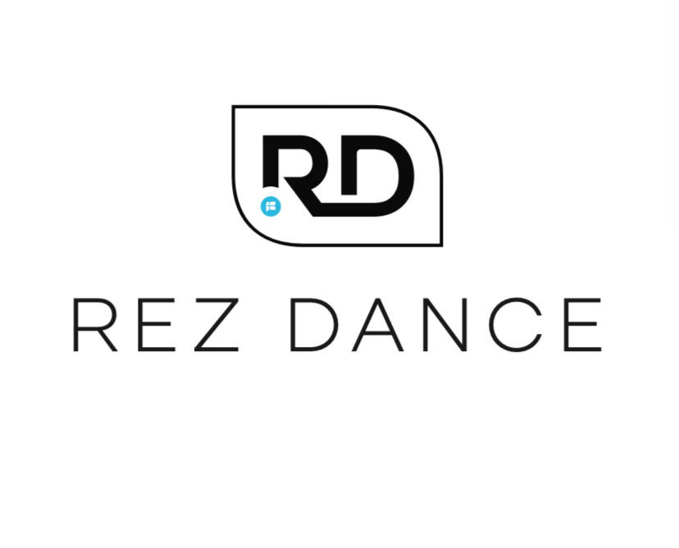
Rez Dance Scholarship Request Form
Please Note: Scholarships are for Sept- May tuition. Scholarships are based on class availability.
Requester is required to pay $35 performance fee/class.

Name of Dancer:_____________________________________________________________________________________________________
Name of Parent/Guardian:___________________________________________________________________________________________
Phone:________________________________________ Email:_________________________________________________________________
Address:_____________________________________________________________________________________________________
City: _______________________________________________ State:__________ Zip:________________________

Do you regularly attend Rez? Yes _______ No _______
Have you received a scholarship for a Rez Dance before? Yes _______ No _______
Have you attended classes at Rez Dance before? Yes _______ No _______
What classes are you interested in? _________________________________________________________________________________
Please tell us why you are requesting scholarship help and what it will mean to you:

Signature:______________________________________________________ Date:_________________________________________________

